**Unit 2 How often do you exercise?**

**Listening test part (共25分)略**

**Written test part (共95分)**

**Ⅴ. 单项选择（每小题1分，共15分）**

从A、B、C、D四个选项中选择可以填入空白处的最佳答案。

(    )21. You can get good at something _______ practice, so just keep trying and learning.

A. from         B. with   C. through            D. over

(    )22. You must keep it in _______ that you are a student and you need to follow the school rules.

A. danger      B. mind        C. place        D. order

(    )23. This kind of coffee is about half the price of that kind of coffee, but there are not many _______ between them.

A. room            B. problems C. time         D. differences

(    )24. _______ you got third place, you tried your best and finished the race.

A. After              B. Although C. Because           D. If

(    )25. —Sam is teaching his 80-year-old grandma to use WeChat these days.

—Oh, really? It's _______ too late for everybody to start learning new things.

A. almost        B. never C. sometimes      D. usually

(    )26. Life is not _______ good, but we have to move on.

A. just   B. often        C. hardly      D. always

(    )27. Zhang Guimei told the girls to find a purpose (目标) in life and live a(n) _______ life.

A. full  B. short        C. terrible     D. early

(    )28. It rained yesterday, but _______ of us was late for school.

A. none  B. any    C. some  D. all

(    )29. I dream of being a doctor. I will never let my dream _______

A. work        B. move        C. die          D. wait

(    )30. The house still needs a lot of work, but _______ we finished cleaning the kitchen just now.

A. at last            B. at least     C. first of all           D. all in all

(    )31. Let's go right now _______ it starts raining hard.

A. but    B. when C. before D. so

(    )32.70 percent of the villagers here _______ the national reading campaign (全民阅读运动). They'd like to read more in 2021.

A. knows             B. doesn't know C. know        D. don't know

(    )33. My parents always _______ lots of time on their phones at home before, but now they _______ their phones quite often.

A. spend; didn't use     B. spent; didn't use

C. spend; don't use      D. spent; don't use

(    )34. —_______ do you have a sports meet in your school, Tim?

—Every year.

A. How often   B. How soon C. How long               D. How much

(    )35. —I decided not to buy that house.

—_______ I thought you wanted it.

A. Lucky you.     B. How come? C. No problem.       D. Can I help you?

**Ⅵ. 完形填空（每小题1分，共10分）**

先通读下面的短文，掌握其大意，然后从A、B、C、D四个选项中选择可以填入空白处的最佳答案。

I play the piano in my school jazz band (爵士乐队). Last month we had a competition (竞赛) with bands from other schools — and our band got a high point!

Our band is great,  36  not everyone can play in it — only the jazz lovers can join our band. Everyone in the band goes to  37  before school starts. And we often spend time  38  after school, listening to jazz and learning its language. There are also trips to jazz summer camps across the country — I went twice and  39  a lot.

Adults (成年人) often  40  why young people are getting interested in jazz. My music teacher thinks it's because jazz isn't  41  for students. That's true. But I like jazz also because I  42  it's exciting, it's both new and old at the same time and it frees my mind and body. Sometimes, it is also a good  43  to make new friends.

We are really  44  because we have great teachers, and our parents support (支持) us all the way. Without (没有)  45 , we'd never get anywhere with our music!

(    )36. A. if                  B. so      C. but     D. because

(    )37. A. practice        B. pay    C. relax     D. worry

(    )38. A. fast              B. together    C. again          D. really

(    )39. A. forgot             B. learnt C. spoke          D. found

(    )40. A. wonder        B. remember   C. show      D. tell

(    )41. A. new              B. old    C. easy       D. hard

(    )42. A. read            B. teach        C. find        D. leave

(    )43. A. life              B. way   C. job            D. term

(    )44. A. young        B. friendly     C. lucky    D. smart

(    )45. A. him              B. her     C. it                 D. them

**Ⅶ. 情景交际（每小题1分，共5分）**

根据对话内容，从方框中选择恰当的选项补全对话，其中有两项多余。

A: Hi, Liu Mei. Are you free this afternoon?

B: Oh, no. I plan (打算) to go to the English Corner (英语角) in the park.

A: Wow! (46)_______

B: Twice a week — every Saturday afternoon and Sunday morning.

A: I see. (47)_______

B: Sure, there are. Half a year ago, I made friends with a girl from the UK.

A: Really? (48)_______

B: Yes, she is. Her parents work in Shenzhen and she studies at a middle school.

A: Great! (49)_______

B: Of course, you can. If you go there, I'll introduce (介绍) you to her and then you can make friends with her too.

A: Cool! Thank you. (50)_______

B: Don't worry! I'm sure you'll have one this afternoon!

|  |
| --- |
| A. Is she living in Shenzhen?  B. Who does she live with in Shenzhen?  C. Are there any English or American people?  D. How often do you go to the English Corner?  E. When did you start to go to the English Corner?  F. May I go to the English Corner with you this afternoon?  G. I really need an English friend to practice speaking English. |

**Ⅷ. 阅读理解（每小题2分，共20分）**

**[A]**

|  |
| --- |
| This winter at the Club Francais  **FRENCH WINTER COURSES**  Jan. — Mar. 2022  **Adults' Crash Course** (速成课) **9 — 18 Jan.**  40 lessons (4 lessons a day)  Each lesson is 50 minutes.  Morning and evening  Price: $600  **Adults' Normal Course** (普通课) **9 Jan. — 4 Mar.**  Twice a week, 1 hour morning or evening  Once a week, Saturday 9 a.m. — 11 a.m.  Price: $278  **Children's Crash Course 11 — 24 Jan.**  3 hours a day, 1 p.m. — 4 p.m.  Years 8 to 12  Price: $630  **Club Francais**  **27 Claire Street, New York**  For more information (信息), call Angela at 860-343-2550. |

根据材料内容选择最佳答案。

(    )51. The Club Francais offers (提供) courses _______.

A. in France B. this summer

C. on the Internet D. on the French language

(    )52. If one takes the Adults' Crash Course, he has to study _______ minutes every day.

A. 50     B. 100   C. 200    D. 250

(    )53. If one takes the Adults' Normal Course, how much does he need to pay?

A. $278. B. $300. C. $600. D. $630.

(    )54. Which of the following children can take the Children's Crash Course?

A. 7-year-old Ann.       B. 10-year-old Peter.

C. 13-year-old Susan.   D. 16-year-old Dave.

(    )55. Which of the following is **TRUE**?

A. The Club Francais is in New York.

B. Angela is the head of the Club Francais.

C. There are no evening classes in the Club Francais.

D. To know more about the Club Francais, one can e-mail Angela.

**[B]**

Golden Hook is a group of grandmas and a young man. They make beautiful hats and sell them all around the world.

You don't buy Golden Hook hats in a shop. If you want one, you need to go to their website (网站) and choose (选择) the size and color you want. Then you look at photos of some grandmas and choose one to make the hat by hand just for you. One week later, you get the hat with a special message from her.

Jeremy Emsellem started Golden Hook in Paris. In 2005, when he was 19, Jeremy began to knit (编织) hats for fun. He wore the hats to school. Other students really liked them. Everyone wanted one! Jeremy made hats for 50 students, but he didn't have time to make hats for everyone.

Then, in 2007, he visited his old aunt and had an idea. His old aunt and her friends had lots of time. They were also very good at knitting. Jeremy asked them if they wanted to make hats. Six of the grandmas said yes. In 2008, Jeremy started the Golden Hook company (公司). In the first year, they only sold 300 hats, but the hats got popular soon. In 2010, Golden Hook had 20 grandmas making those beautiful hats.

Jeremy is happy that Golden Hook lets people get excellent hats and helps grandmas get money and something interesting to do.

根据材料内容选择最佳答案。

(    )56. How can we get a Golden Hook hat?

A. By going to its shop.    B. By visiting its website.

C. By leaving a message. D. By making a phone call.

(    )57. Why did Jeremy knit hats at first?

A. To have fun.    B. To make money.

C. To look cool at school.        D. To help his classmates.

(    )58. Who helped Jeremy with the start of his company?

A. His friends.     B. His classmates.

C. His aunt and her friends.  D. His grandma and her friends.

(    )59. Which word can we use to describe Jeremy?

A. Smart.             B. Strict.      C. Friendly.     D. Interesting.

(    )60. The writer wrote the passage to _______.

A. tell us how to open a company

B. ask us to buy Golden Hook hats

C. tell us the story of Golden Hook

D. ask more grandmas to knit hats

**Ⅸ. 词汇运用（每小题1分，共10分）**

A) 根据句意及所给汉语提示，写出所缺单词。

61. Don't tell people how to do things; tell them what to do and let them surprise you with their _______(结果).

62. With the help of a dictionary, I can read some English _______(杂志).

63. Doing the ________(家务劳动) is not only the parents' job. Children can help parents to do some.

64. They lost the basketball game by three _______(分) to four.

65. Remember, we have two ears and one mouth, so let's speak _______(较少) and listen more.

B) 根据句意及所给首字母提示，补全所缺单词。

66. A good diet (饮食) and much exercise can help you to keep your b                healthy.

67. These TV p                are really boring. Let's go out for a walk.

68. I went to the d                and had two teeth out yesterday.

69. Ba Jin, Qian Zhongshu and Cao Yu are all my favorite Chinese w               .

70. There are about 15,000 to 20,000 kinds of butterflies in the world. They live a

everywhere all over the world.

**Ⅹ. 完成句子（每小题2分，共10分）**

根据汉语意思，完成英语句子，每空一词(含缩略形式)。

71. 这趟列车经过很多重要城市，例如天津、济南和南京。

The train passes by many important cities _______ _______ Tianjin, Jinan and Nanjing.

72. 大多数垃圾食品含糖量很高。

Most _______ _______ is high in sugar.

73. 通往广场的路不止一条。生活亦是如此。条条大路通罗马。

There is _______ _______ one way to the square. Life is like that. All roads lead to Rome.

74. 在工作中保持快乐是很重要的。

_______ _______ _______ be happy in your work.

75. 也许他在他的办公室里。

_______ _______ _______ in his office.

**Ⅺ. 综合填空（每小题1分，共10分）**

阅读短文，从方框中选择恰当的词并用其适当形式填空，使短文完整、通顺。每词限用一次。

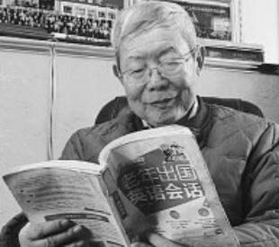

|  |
| --- |
| they, before, important, get, online, problem, try, however, people, live |

One Monday evening, 90-year-old Zhang Minghe opened an English book and started a group discussion (讨论) through WeChat.

Zhang is the teacher for the (76)_______ study group. He started the group in January, 2019. He gives three classes a week and has spent more than 100 hours teaching. Student Liu Ze, 72, said, “Zhang (77)_______ to help us learn English. He is our role model (榜样).”

Zhang worked as a teacher (78)_______ he retired (退休). But he didn't teach English. Zhang found more and more (79)_______ spoke English around the world. Then he taught himself English. He worked hard and (80)_______ really good at it. After he retired, he worked as a technical translator (技术翻译). At the age of 75, he stopped the work as a translator. (81)_______, he didn't stop learning. He goes on learning English at Taiyuan Seniors' College (老年大学).

Zhang (82)_______ far from the college. And he has difficulty walking because of leg (83)_______. But he's never late for class. He's happy with his life. He thinks it's important for old people to make use of (84)_______ time to do something.

“Learning is a very (85)_______ thing and we must keep learning all our life,” said Zhang.

**Ⅻ. 书面表达（15分）**

假如你是某校八年级二班的学生王宁，你班英语老师兼班主任让你对你班学生课外活动的情况进行一次调查（survey）并要求你在下节英语课上将该调查结果介绍给你班同学，请你根据下面的调查结果及内容提示写一篇短文为此做准备。

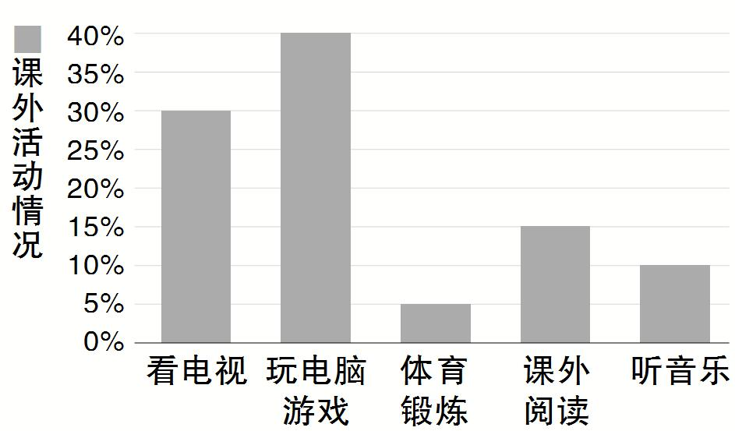

**内容提示：**

1. 介绍调查结果；

2. 谈一谈你对此结果的看法或建议。

**要求：**

1. 应包含以上内容提示，可适当发挥；

2. 语言表达要准确，语义通顺、连贯；

3. 词数不少于100，文章开头已给出，不计入总词数。

Hi, everyone! Last week, Miss Li asked me to find out what we usually do after school. Here are the results of the survey. _________________________________________________________________________________________________________________________________________________________________________________________________________________________________________________________________________________________________________________________________________________________

**◆  附加题（共10 分）  ◆**

Last week we went on a school trip. We visited a very special place in Turkey — the Hair Museum. There are so many locks (缕) of hair in it.

The story goes that a man's good friend was going to leave him. He asked for something to help him remember her. She cut off a lock of her hair and gave it to him. He put it up in his shop, and he told the story to all the people visiting his shop. Many women enjoyed the story and left a lock of their hair too.

The man started the Hair Museum in 1979. It now has about 16,000 locks of hair. There's also another reason (原因) to leave some hair. Twice a year the museum holds (举行) a competition and decides which lock of hair is the best. If your hair wins (获胜), you can stay for one night in the hotel next to the Hair Museum for free in the summer months.

A number of people visit the Hair Museum every day. Visitors can walk down the museum seeing the hair in different colors and lengths. If visitors want to leave their locks of hair to the museum, there are pencils, paper and scissors (纸和剪刀) for them. They need to write their name and age on the paper.

根据短文内容完成句子。

1. The man's _______________ gave him a lock of hair before she left him.

2. The Hair Museum started in the year of _______________.

3. The Hair Museum holds a competition _______________ a year.

4. If you win the competition, you can spend _______________ in a hotel for free.

5. If you want to leave your hair to the museum, you need to write your _______________ on a piece of paper.

**参考答案**

Listening test part (略)

Ⅴ. 21-25 CBDBB  26-30 DAACB  31-35 CCDAB

Ⅵ. 36-40 CABBA  41-45 DCBCD

Ⅶ. 46-50 DCAFG

Ⅷ. 51-55 DCABA  56-60 BACAC

Ⅸ. 61. results  62. magazines  63. housework  64. points  65. less

66. body  67. Programs 68. dentist  69. writers  70. almost

Ⅹ. 71. such as  72. junk food  73. more than / not only  74. It's important to

75. Maybe he is / He may be

Ⅺ. 76. online  77. tries  78. before  79. people  80. got

81. However  82. lives  83. problems  84. their  85. important

**Ⅻ. One possible version:**

Hi, everyone! Last week, Miss Li asked me to find out what we usually do after school. Here are the results of the survey. Thirty percent of us watch TV at home. Forty percent play computer games. Fifteen percent read books and ten percent listen to music. I'm surprised that only five percent do some exercise!

From the result, we can see that most of us use the Internet or watch TV in our free time. We usually sit for hours but don't do any exercise. We all know this is not good for our health. I think we should spend more time exercising. Different kinds of exercise such as playing ball games or running can make us feel good and they also help us do well at school. So let's sit less and move more from now on.

**附加题**

1. good friend  2. 1979  3. twice  4. one night  5. name and age